**COS 221**

**Practical Assignment 4**

**Scott Bebington**

**U21546216**

**Task 1**

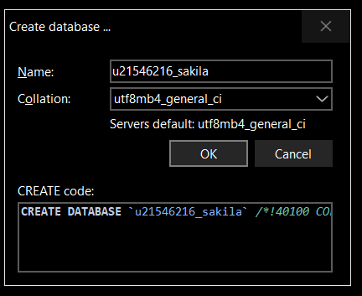

**Task 2**

2.1) I have used MySQL Workbench

2.2)

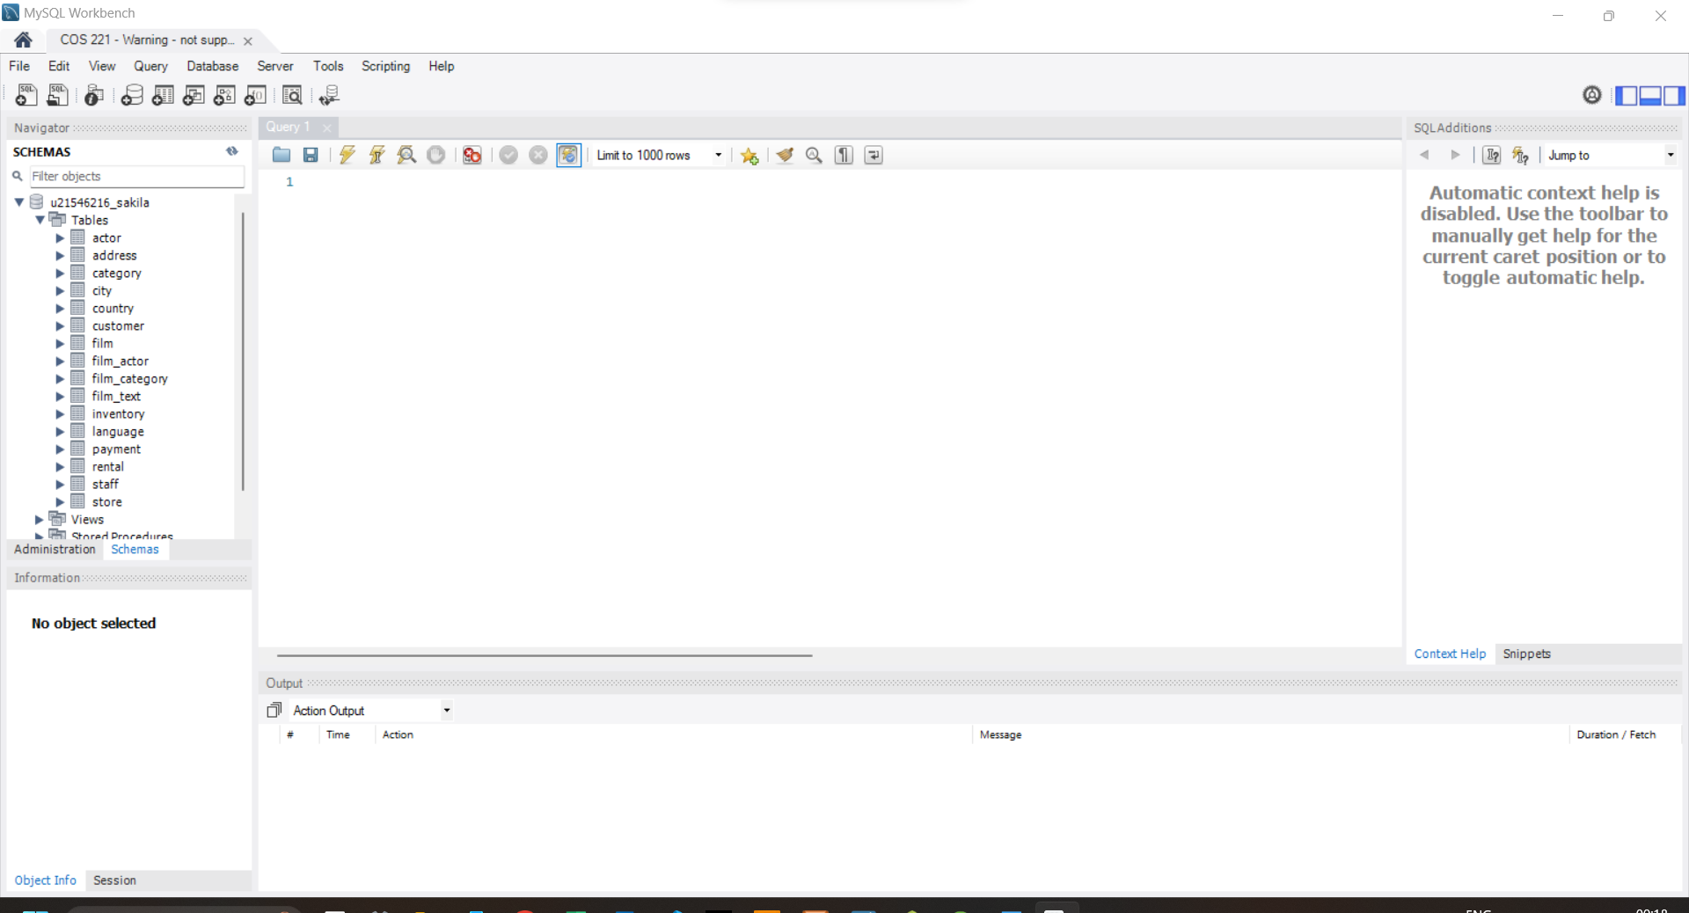

**Task 3**

3.1)

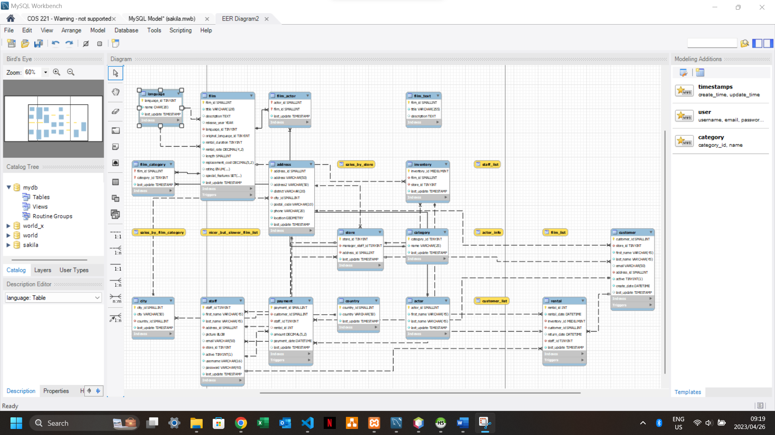

3.2) The Store table has the following attributes

store_id: hold the unique id of the stores

Constraints: Cant be longer than 3 digits, must be unique, is the primary key

Data Type: TINY INT(3)

manager_staff_id: holds the unique id of the manager that works in the store

Constraints: Cant be longer than 3 digits, must be unique

Data Type: TINY INT(3)

address_id: holds the unique id of the address of the store

Constraints: Cant be longer than 5 digits, must be unique

Data Type: SMALL INT(5)

last_update: this field is less important as it just stores the last time the rows were updated.

Constraints: Must be in date and time format

Data Type: TIMESTAMP

This table is very important to the Database as it provides a lot of links to join tables on and find data easily, it joins almost every table together.

**Task 4**

4.1)

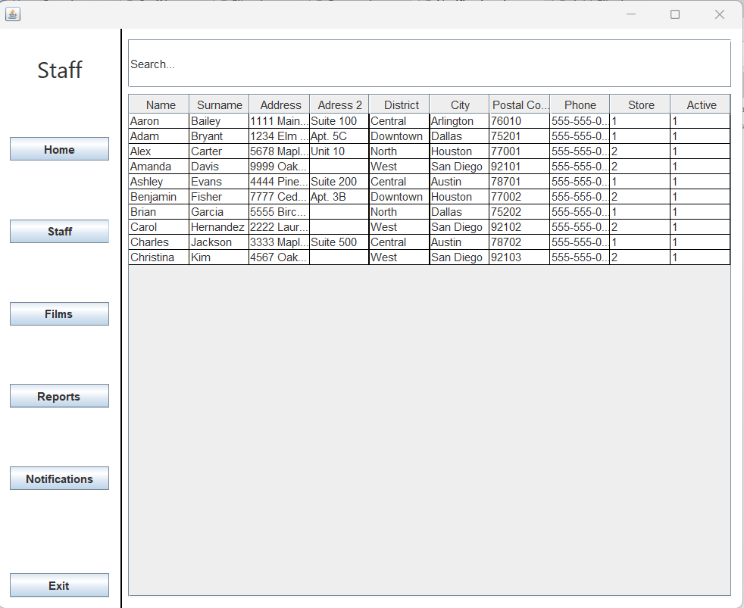

4.2)

4.3)

4.4)

4.5)

4.6)

**Task 5**

I used environment variable and GitHub.